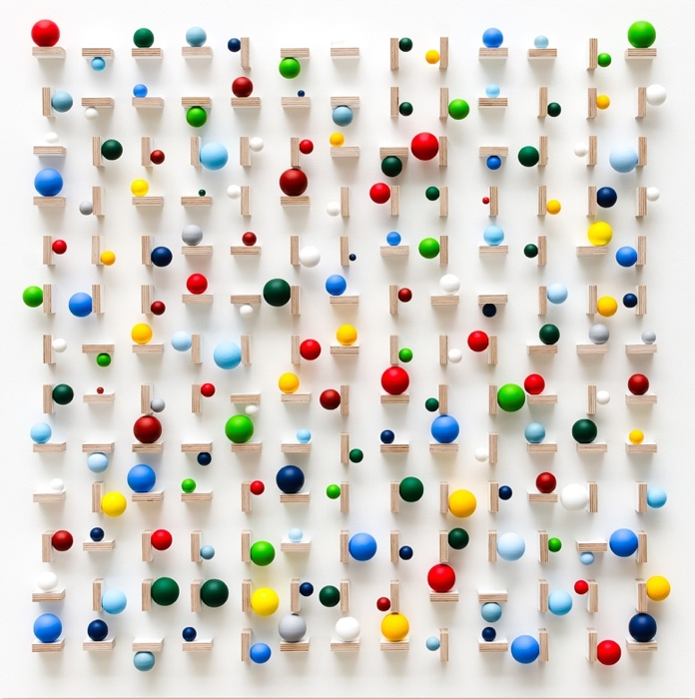

PRESS RELEASE
42nd Annual Exhibiton
Opens 8th June 2024

Thompson’s Gallery, Aldeburgh are yet again opening their doors to host our 42nd Annual Exhibition to be held in June. We will be showing new work by over 50 artists which will be in different style, technique and medium. As we do every year, we are showing works of art from both the 20th Century and 21st Century and have carefully chosen pieces of only the highest quality and representation. We have artists from all over the UK sending in their work and also a handful from abroad such as South Africa and Belgium. On the 20th Century side of things we have works by Edward Seago and John Piper, Harry Becker, Craigie Aitchison, Anne Cotterill and Fred Yates.

On the Contemporary side we have work by Stuart Hartley, who is new to the gallery, Francis Boag, Jonathan Robertson, Sandy Murphy, Nick Botting, Muriel Barclay, Ben Lowe, Morag Muir and Stephanie Rew. We will also be showing some stunning sculptures by Mel Fraser who is also new to the gallery. Her delicate yet strong sculpting in selenite from various countries are truly exciting. We will also be showing new imported work by the South African artist Rene Snyman who has proven to be very popular with our clients especially her large landscapes and her exquisite use of light.

Alongside the Annual Exhibition we are also putting on a sculpture exhibition which will be on display in our new sculpture garden. We have chosen works by 7 well established sculptors such as Jim Unsworth, Paul Vanstone, Chris Marvel, Vanessa Pooley, Jonathan Clarke and Richard Holliday.

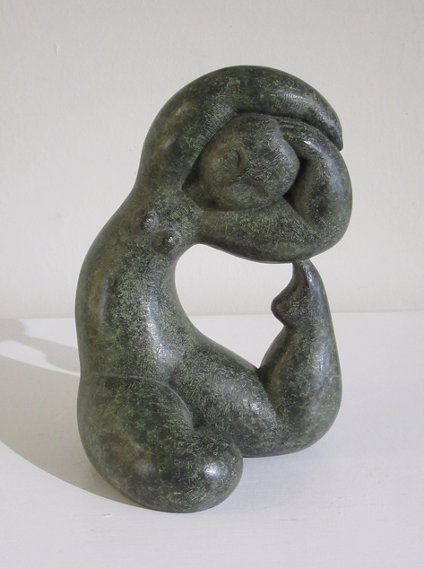
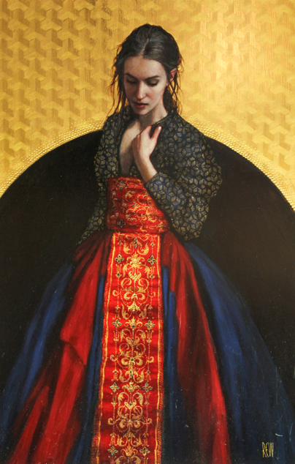

For further information or to request higher resolution images please contact: Camilla McCausland, Thompson’s Gallery, 175 High Street, Aldeburgh, Suffolk, IP15 5AN Tel. 01728 453743 email. camilla@thompsonsongallery.co.uk

