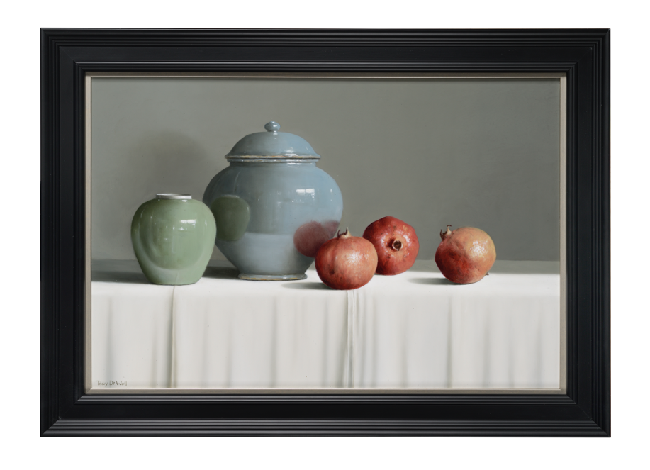

PRESS RELEASE
TONY DE WOLF
Solo Exhibition
Opens 29th July 2023

Thompson’s Gallery, Aldeburgh will be holding a solo exhibition by the still life painter Tony de Wolf. We have been Tony’s UK representative for over 10 years now and he has proven to be extremely popular with clients and visitors alike. His very precise and perfect still lifes in the vein of the Dutch masters show how he is exact in his execution and has a high level of craftsmanship with a strive for precise representation of the objects he paints. Most of his compositions are traditional still lifes, the objects arranged to show light and shade, colour and contrast and it draws us into the wonder of his realism with familiar and reassuring compositions. He selects the objects in his work carefully and plays with different compositions and colours to finally settle to paint with oil so carefully applied it is without brush strokes giving the works a sense of hyper realism. Although complex in the execution his work has a simplicity about it, a purity that focusses on the objects alone and where they have been placed. As a student de Wolf greatly admired 17th Century Flemish painters and began copying them as a way of learning to draw and paint. After seven years at the Academy of Fine Arts in Antwerp under the tutelage of Willem Dolphyn, de Wolf settled on a style which he has spent years perfecting. Although at first glance his still lifes appear very traditional there is also a modern simplicity to them which makes them somewhat ageless.

Artist’s statement: “It is the timeless quality of still life painting that appeals to me so much. Although I studied and apply the Old Masters techniques and their chiaroscuro, I use lighter backgrounds. I think art must evolve and be inspired by an artist’s own society. Setting up a composition takes a long time and when I’m finally happy about it, it feels like the work is half done. I prefer soft colours for my contemporary objects, however I also like to include Items that are hundreds of years old, even with imperfections or scars because of their eternal beauty. In our stressful world, still life paintings give us a chance to simply stand still and admire. I’ll conclude with a quote of the great poet John Keats that says it all: “A thing of beauty is a joy for ever.”
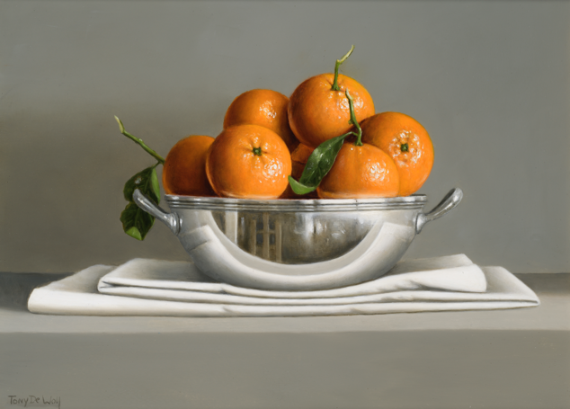
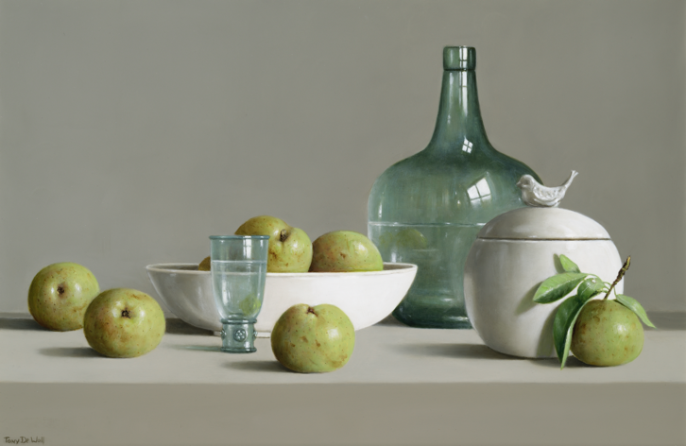

For further information or to request higher resolution images please contact: Camilla McCausland, Thompson’s Gallery, 175 High Street, Aldeburgh, Suffolk, IP15 5AN Tel. 01728 453743 email. camilla@thompsonsongallery.co.uk

