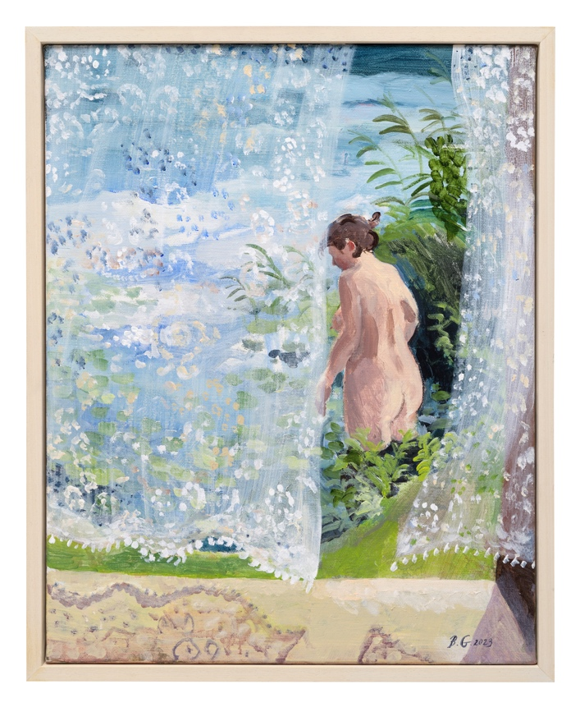

PRESS RELEASE
Brita Granström
‘Dreams on a Summer Night’
Opens 27th July 2024

Brita was born in Sweden in 1969, in the ethereal landscape of the county Södermanland which is rich in forestry and lakes. She grew up on a farm next to one of the largest lakes in Sweden called Hjälmaren and to this day this is where Brita draws a great deal of her inspiration from when she stays in her rural cottage by the lake every summer. In this new exhibition of interiors and seascapes called ‘Dreams on a Summer Night’ she invites us to her summer house to spend that long midsummer night, a time when reality and dream seem to blur. We join her to gather blueberries, have dinner and later we may even visit her jetty where we can take the plunge and swim in the dark coloured water among the flowering rushes.
Brita trained at the esteemed Konstfack in Stockholm where she was taught to hone her craft and experiment with different media and techniques and she subsequently settled on a wonderfully loose and skilled application of acrylic on canvas which is her preferred medium to date. She has lived in the UK since 1993, on the North East coast, painting interior scenes from her domestic life as well as the seascapes on her doorstep. Brita beautifully captures in her paintings those intimate and tender moments in every day life, so often missed or ignored.
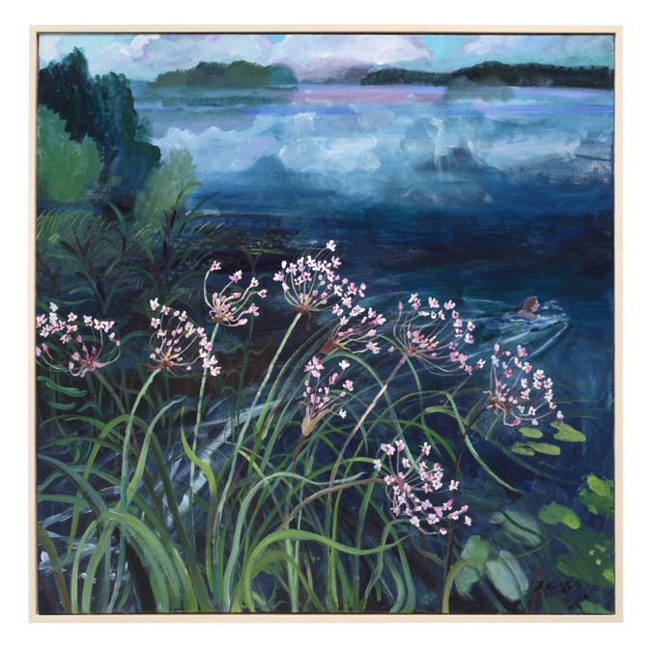
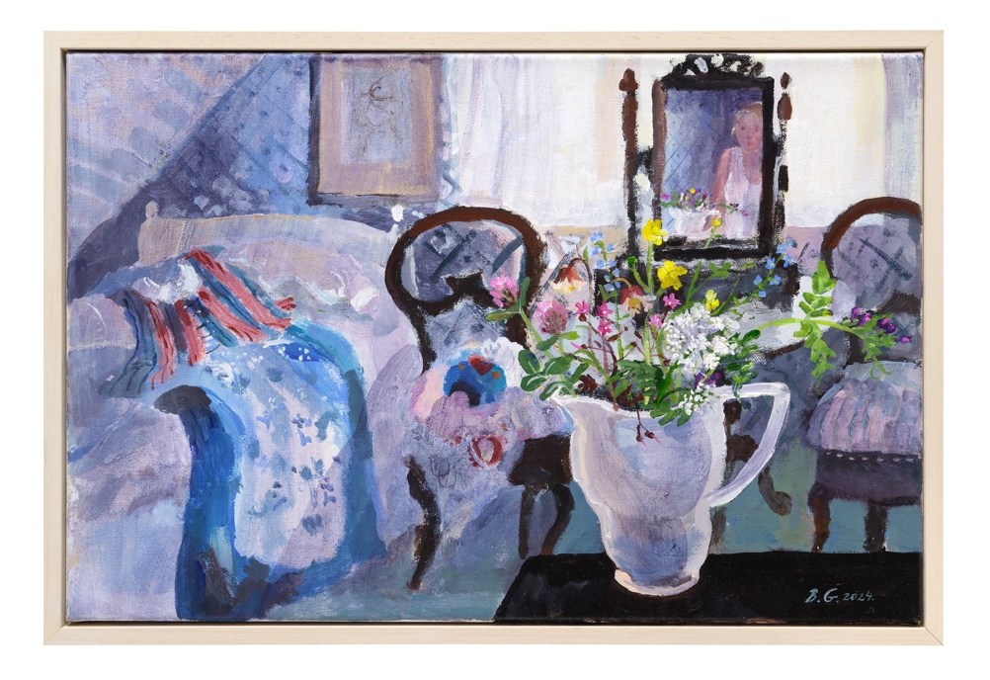
The last exhibition Brita had with Thompson Galleries was entitled ‘Leaves of Lockdown’ and was a sell-out. Her paintings are in many private and public collections around the world and she has also appeared on television and radio.

For further information or to request higher resolution images please contact: Camilla McCausland, Thompson’s Gallery, 175 High Street, Aldeburgh, Suffolk, IP15 5AN Tel. 01728 453743 email. camilla@thompsonsongallery.co.uk

