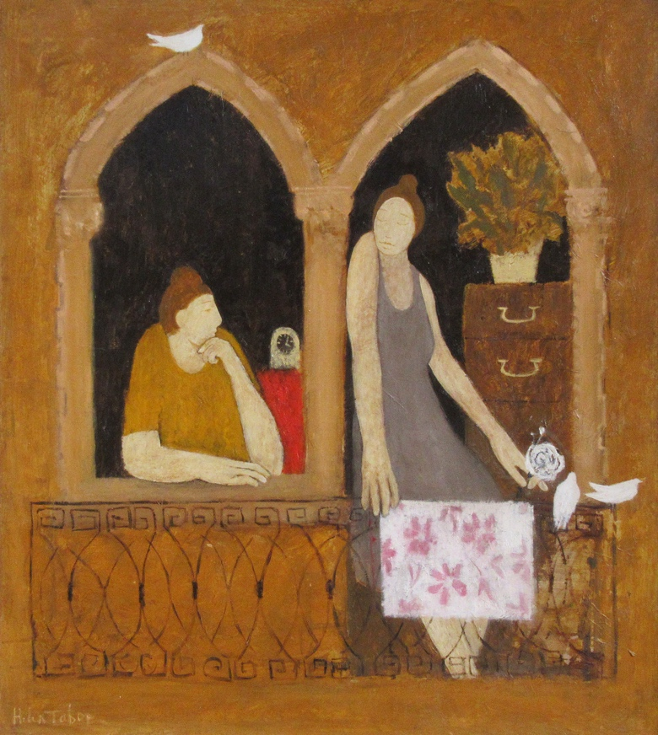**\\SERVER\shared\Devi's Folder\Devi's Letters\Thomp Logo's\Thompson's Alde.tif**

**PRESS RELEASE**

**Venice**

**‘Through the Artists Eyes’**

**Opens 16th August 2024**

Thompson’s Gallery, Aldeburgh are having a group exhibition showing work by several different artists with views and impressions of Venice in Italy. We have deliberately chosen different media and subjects in order to give the exhibition width and breadth and also the unique perspective that can be offered through different artists eyes. We have works by such wonderful artists as John Piper, David Sawyer, Norman Smith, Martin Yeoman, Helen Tabor, Jack Morrocco and Margaret Glass. It is an uplifting exploration of the main iconic Venetian attractions as well and scenes from everyday life, laundry hanging in a back alley, people enjoying lunch in a café, gondolas ferrying passengers along the canals.

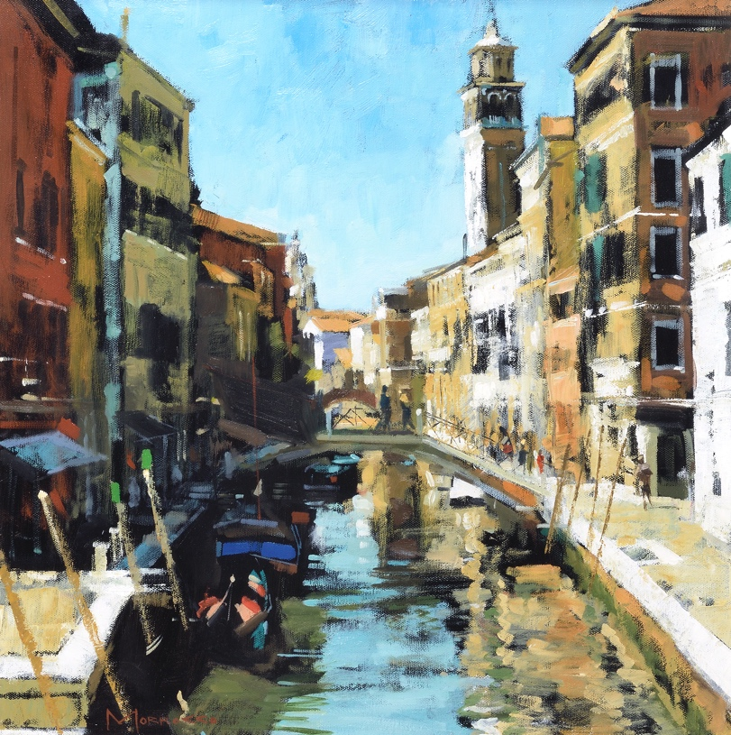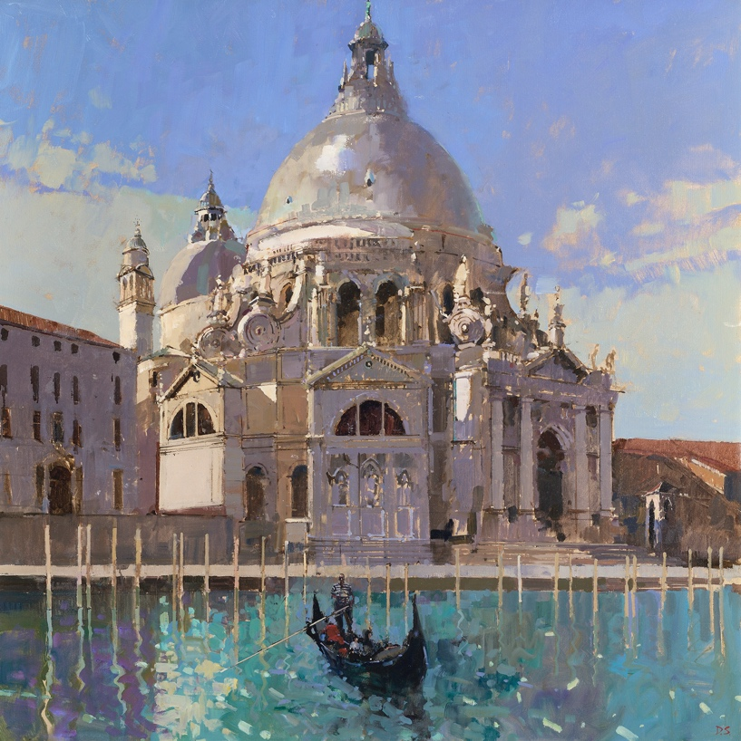

For further information or to request higher resolution images please contact: Camilla McCausland, Thompson’s Gallery, 175 High Street, Aldeburgh, Suffolk, IP15 5AN Tel. 01728 453743 email. [camilla@thompsonsongallery.co.uk](mailto:camilla@thompsonsongallery.co.uk)